**AZURE ML**

Azure ML is the platform we will be using to train the model.

Free tier will get 200$ but you need to give your Card information [You might face issues here if you don’t have an international debit card or credit card]. Students get 100$ of resources to use within a period of 1 year [Card information not needed].

Resources can mean anything from storage to compute instances. Compute instances are the cloud computers you will be using to train the model. A computer instance with a GPU will make things way faster but they are more expensive.

**1. Workspace**

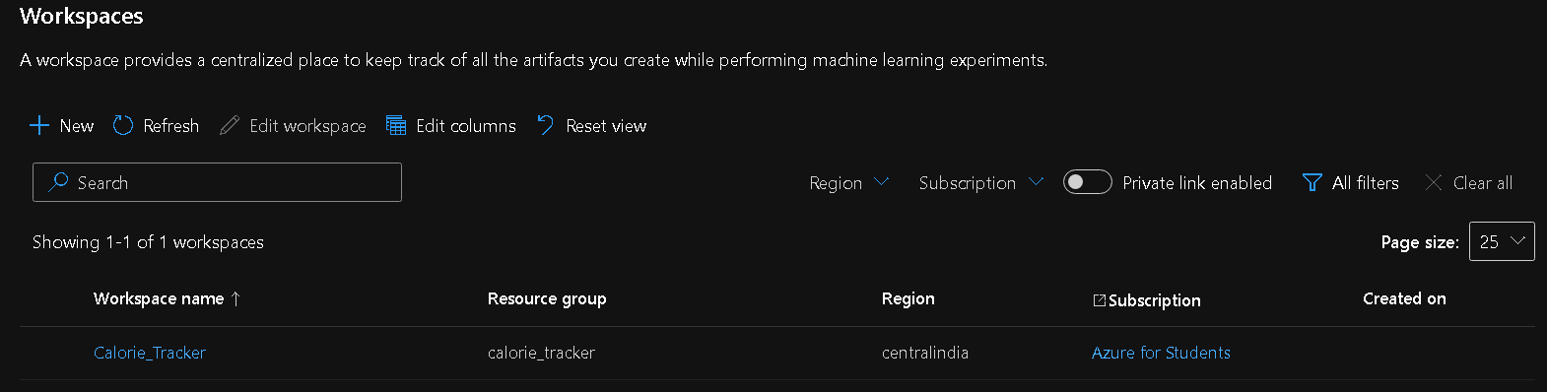

**Click New and follow default settings for the workspace.**

**After creation, click on the workspace where you will land in this page:**

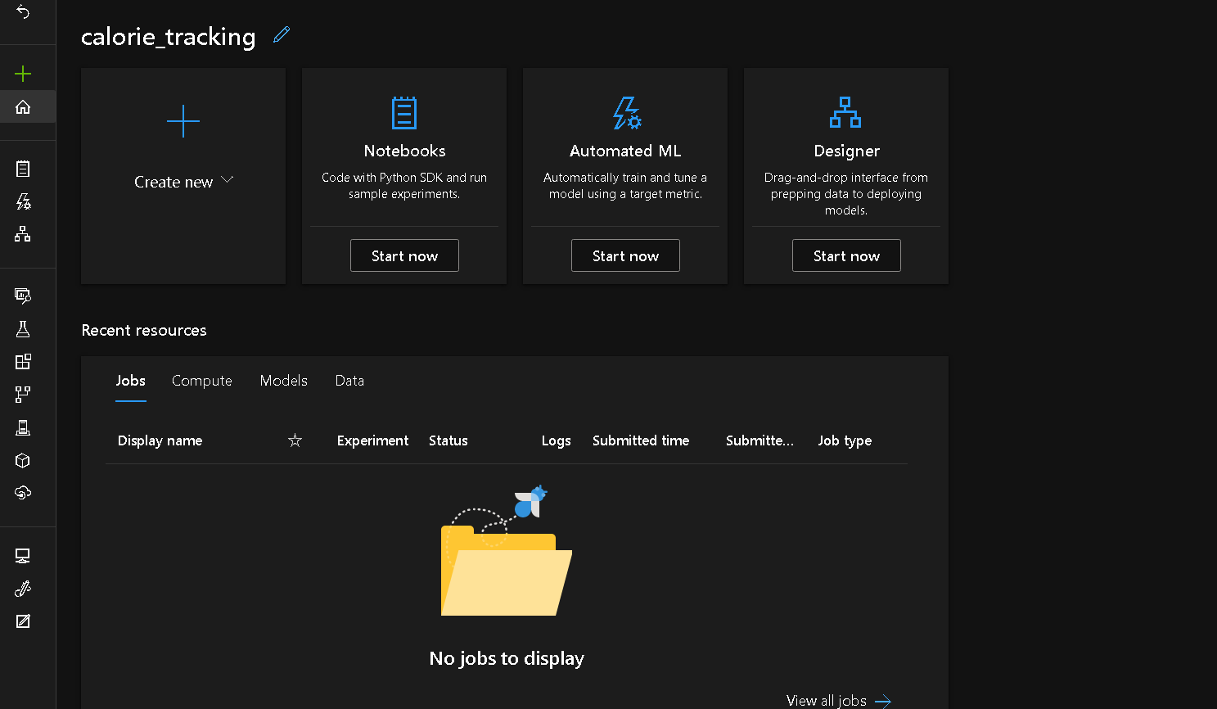

**2.**  **Compute Instances**

**In the side panel, under Manage, go to Compute.**

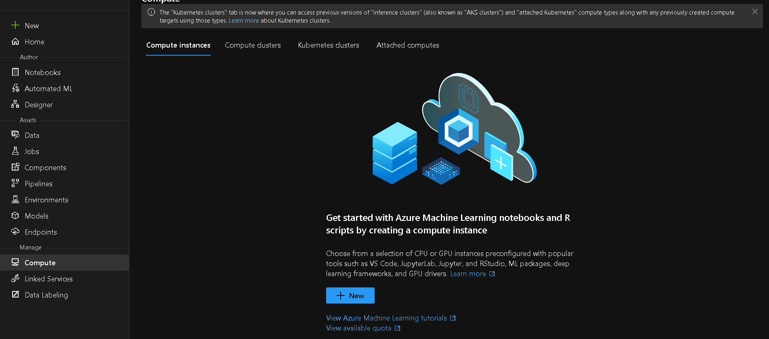

**Click on New,**

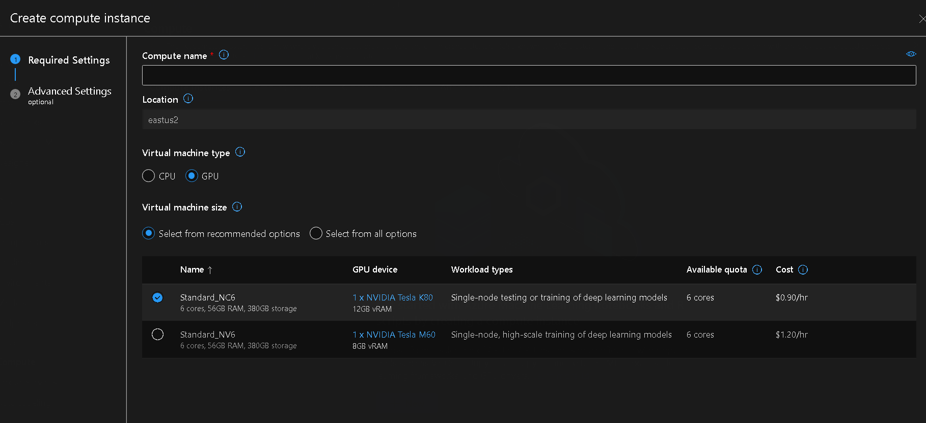

**Create a compute instance using a configuration of your choosing. GPU more expensive but will train faster so cost/time trade-off needs to be checked between GPU and CPU.**

**We trained the previous model using GPU which took approximately 4 hours per EPOCH.**

**We trained only for 14 epochs which means around 56 hours of training.**

**At the time, 1.72$/hr for the compute instance with GPU which means 96.32$.**

**DON’T EVER LEAVE THE COMPUTE INSTANCE ON ACCIDENTALLY AND MAKE SURE EVERYTHING IS SET UP BEFORE SWITCHING IT ON TO REDUCE OPERATING TIME.**

**3. Notebooks**

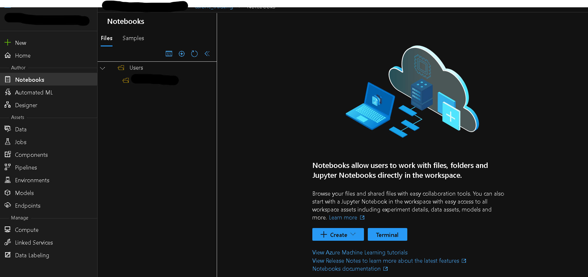

**Upload** [**Faster_RCNN_Azure_ML_2.ipynb**](https://github.com/DeveloperVivek9/Calorie-Tracker/blob/main/Machine%20Learning/Faster_RCNN/Faster_RCNN_Azure_ML_2.ipynb)**. In the same directory, upload train and test folders. Train_Labels.csv + Test_Labels.csv + Classes_List.csv are the three files needed for the model.**

**Classes_list.csv to get the classes for classification.**

**Test_Labels.csv/Train_Labels.csv for bounding box information of test/train folder respectively.**

**Follow ipynb file and change path and name of any file if there are any changes on your part.**

[**VIEW BALANCE**](https://www.microsoftazuresponsorships.com/Balance)